**ΧΟΡΗΓΟΣ ΜΕΤΑΚΙΝΗΣΕΩΝ**

[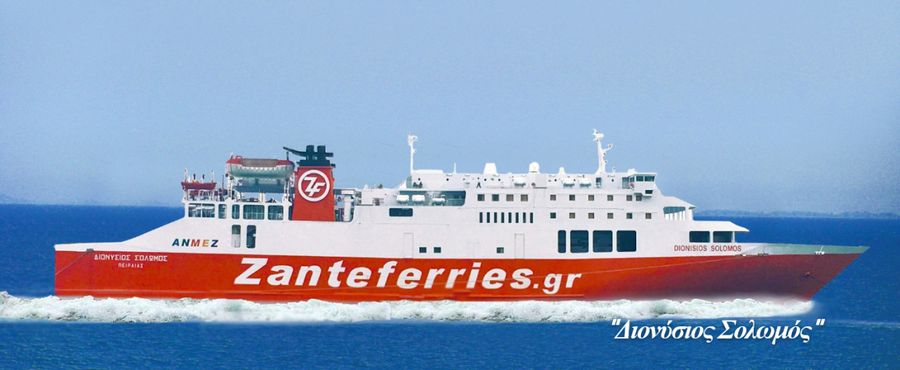](http://zanteferries.gr/)

**ΧΟΡΗΓΟΙ ΔΙΑΜΟΝΗΣ**

**[](https://www.kimoliagi.gr/)**

**[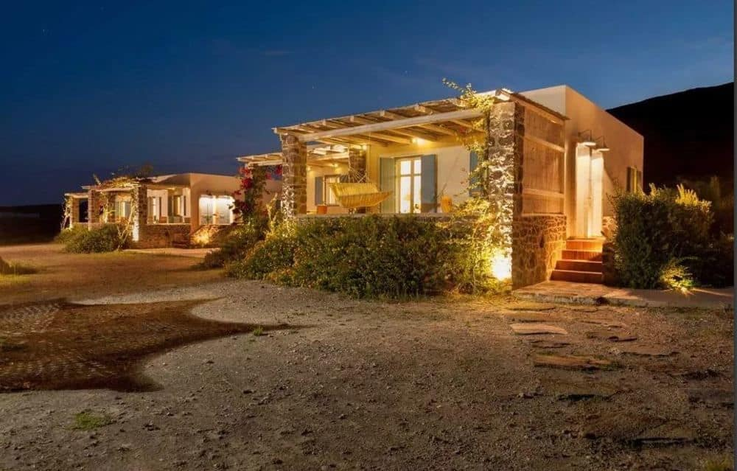](https://www.kimoliagi.gr/)**

**[](https://www.ariahotels.gr/content/kimolosblue/welcome-21)**

**[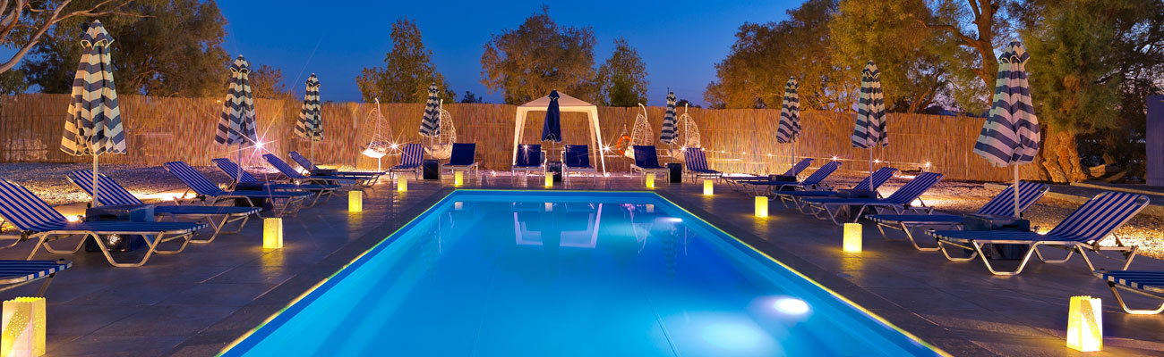](https://www.ariahotels.gr/content/kimolosblue/welcome-21)**

**ΧΟΡΗΓΟΙ ΔΙΑΤΡΟΦΗΣ**

**[](http://www.kalikardia-kimolos.com/el/)**

**[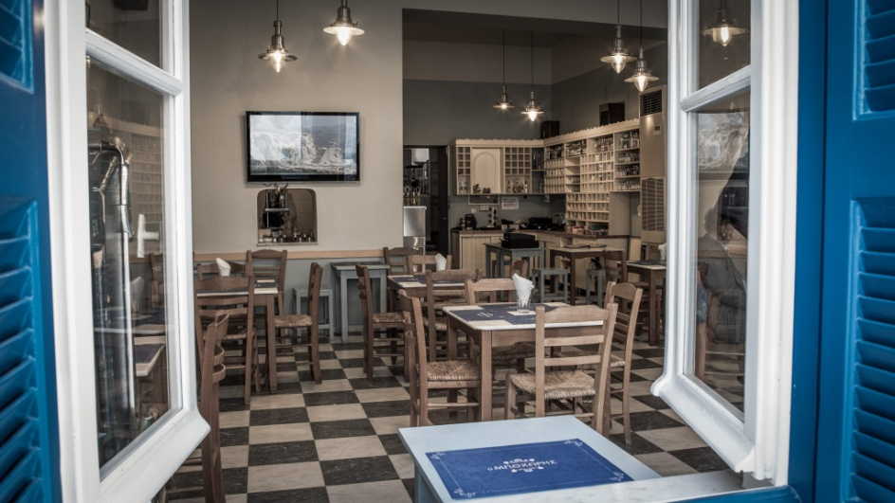](http://www.kalikardia-kimolos.com/el/)**

[**Κύμα**](https://web.facebook.com/%CE%A4%CE%BF-%CE%9A%CF%8D%CE%BC%CE%B1-%CE%BC%CF%80%CE%BF%CF%87%CF%89%CF%81%CE%B1%CE%BA%CE%B9%CE%B1%CE%9A%CE%B9%CE%BC%CF%89%CE%BB%CE%BF%CF%82-844740789003944/?_rdc=1&_rdr)

[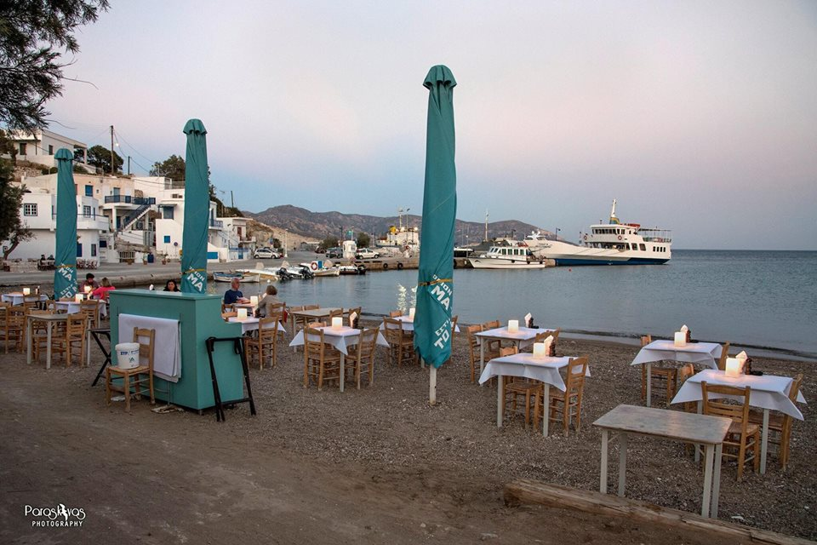](https://web.facebook.com/%CE%A4%CE%BF-%CE%9A%CF%8D%CE%BC%CE%B1-%CE%BC%CF%80%CE%BF%CF%87%CF%89%CF%81%CE%B1%CE%BA%CE%B9%CE%B1%CE%9A%CE%B9%CE%BC%CF%89%CE%BB%CE%BF%CF%82-844740789003944/?_rdc=1&_rdr)

[](http://kimolos-meltemi.gr/estiatorio)

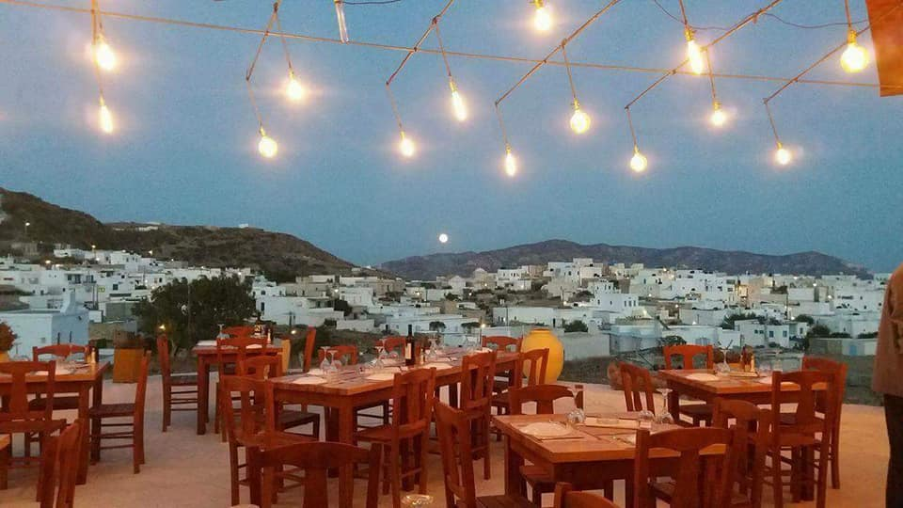

**[](http://www.postali-kimolos.com/el/)**

**[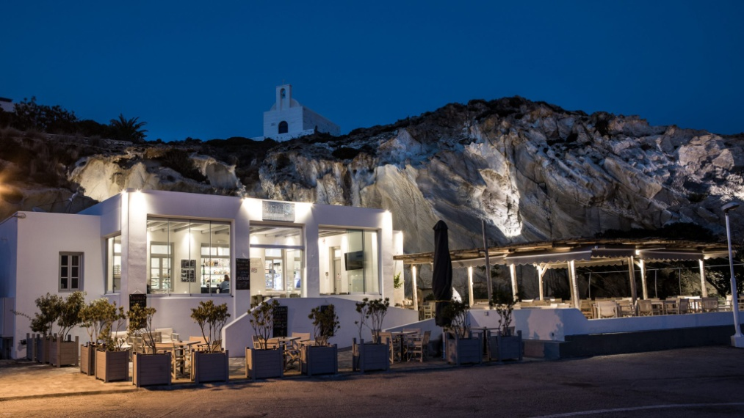](http://www.postali-kimolos.com/el/)**

[](https://www.kimolosrooms.com/%CE%B5%CE%BB%CE%BB%CE%B7%CE%BD%CE%B9k%CE%B1/%CE%B5%CF%83%CF%84%CE%B9%CE%B1%CF%84%CF%8C%CF%81%CE%B9%CE%BF/)

[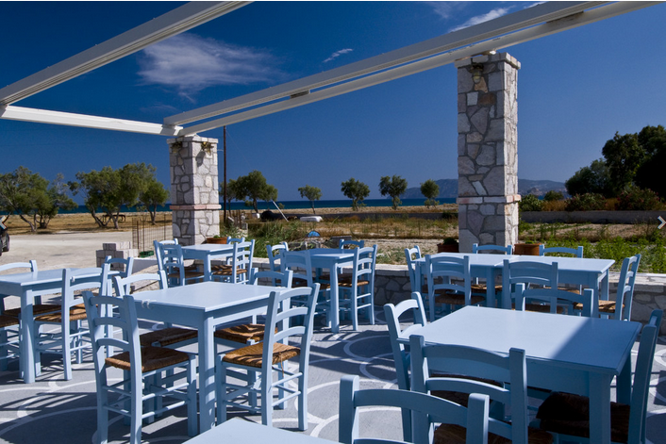](https://www.kimolosrooms.com/%CE%B5%CE%BB%CE%BB%CE%B7%CE%BD%CE%B9k%CE%B1/%CE%B5%CF%83%CF%84%CE%B9%CE%B1%CF%84%CF%8C%CF%81%CE%B9%CE%BF/)